[INSTRUCTIONS: Below is an example of how to format your Course Project paper. DELETE all text between braces [] and replace that text with your own words. Keep the text that is NOT between braces [] as it will help you structure your submission. Be sure to review the Ten Tips for Computer Science Essay Success at the end of this template.]

[Title Here]

Lane Dorscher
CS200-T301 Systems Fundamentals (2261-1)
Bellevue University
[Date Here]
Joseph Kovacic

Introduction
[Write at least one paragraph that describes what your paper will cover. It should be 150-200 words. Your Introduction should contain a thesis statement. A good thesis statement in an Introduction looks like this: “This paper will compare JavaScript to C in order to establish which best meets the ABC Corporation need for a portable programming language.” Here is another example: “There are five key features of the C++ programming language that effectively address current engineering challenges.” Remember, a key feature of an Introduction is that it is written in the FUTURE tense.]

[First-Level Heading]
[Your words here. Remember to use paragraphs that are at least 150 words in length. Do not use personal pronouns such as I/me, and do not use contractions (e.g., can’t, won’t, shouldn’t, etc.).]

[First-Level Heading]
[Second-Level Heading]
[Your words here. You can also split paragraphs under a first-level heading into segments labeled with second-level headings (See the OWL example for details). ]
[Second-Level Heading]
[Your words here.]

[First-Level Heading]
[Your words here. Remember, you do not have to use first-level headings, but there is a HUGE advantage. You can use first-level headings to mirror the assignment instructions and clearly show your professor that you addressed each prompt. Newer students often paste the assignment instructions into an MS Word document and then type text under each instruction that addresses the assignment requirements.
A better method is to list first-level headers that PARAPHRSE the assignment instructions. For example, let us say the first assignment question for the week is “What are the three primary components of a modern computer?” Rather than paste that question into this template, you would do the following using first and second-level headings:]
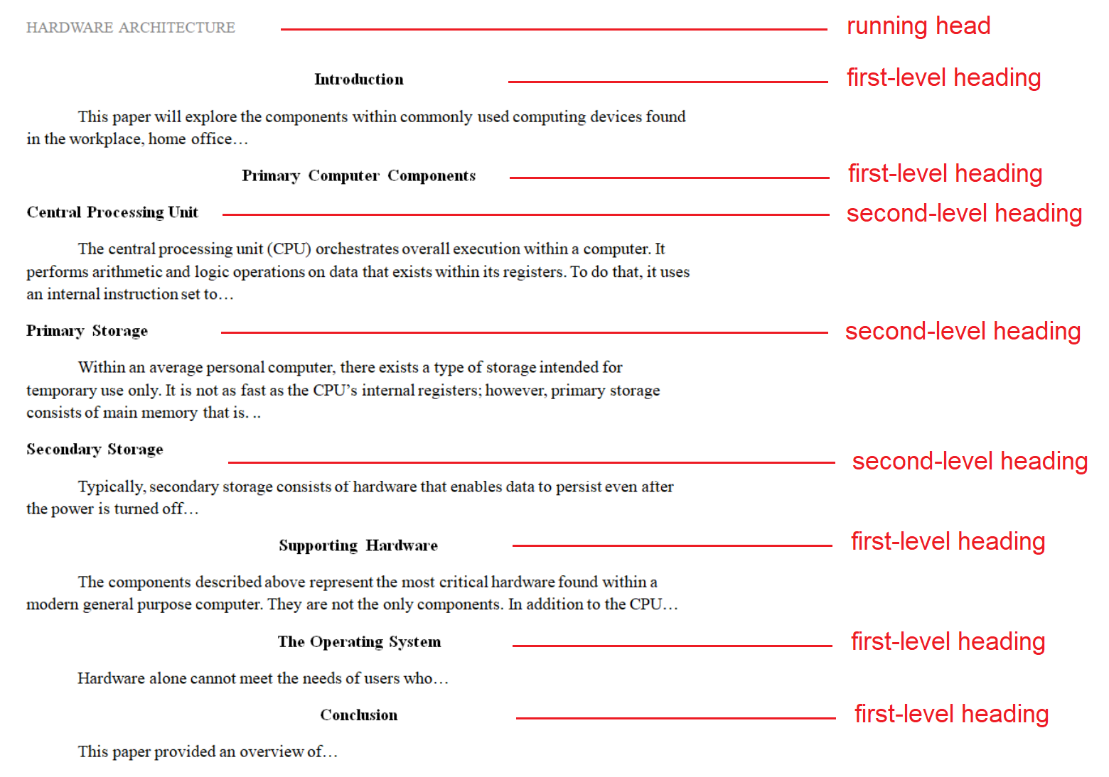
[Figure 1: Delete the illustration above before submitting your paper.]

Conclusion
[Your words here. The Conclusion is written in the past tense. No new material or citations go here because you are summarizing the existing material you covered above.]

References
[references should begin on a new/separate page]
[1st Author Last Name, First Initial. (Year Here). Title Here. Place other APA formatted text about the source here.
2nd Author Last Name, First Initial. (Year Here). Title Here. Place other APA formatted text about the source here.
3rd Author Last Name, First Initial. (Year Here). Title Here. Place other APA formatted text about the source here.
Nth Author Last Name, First Initial. (Year Here). Title Here. Place other APA formatted text about the source here.]

[DELETE ALL PAGES THAT FOLLOW (PAGES 6-8) FROM YOUR SUBMISSION]
Ten Tips for Computer Science Essay Success
Review these tips, but be sure to delete them, as well as all red text in this document, before submitting your paper. To create quality submissions, you should be familiar with the core components of high-quality undergraduate work. If you are unfamiliar with the terms paraphrasing, in-text citation, and synthesis you should research them prior to submitting discussion board posts or written papers in this course. Here are some helpful links:
Citing Sources:
https://www.youtube.com/watch?v=hhD4xaGAcRs&ab_channel=Scribbr
Paraphrasing: https://www.youtube.com/watch?v=0mF0mFwlnAY&ab_channel=LearnAcademicEnglish
Synthesis:
https://www.youtube.com/watch?v=ObK6J7vGnw8&ab_channel=USULibraries
Using the Third Person:
https://www.youtube.com/watch?v=K6o2IsHGc98&t=5s&ab_channel=BryanCorbin

What You SHOULD Do in Your Essay
1. Cite Your Sources: Use sources in addition to the course textbook for discussion boards and written papers. Reading broadly to develop insights (from multiple authoritative and credible sources) is expected. Review the grading rubric carefully to understand the difference between an “unsatisfactory” and “excellent” grading criterion.

2. Use Your Student “Voice”: Use your own words. Paraphrase what you read vs. merely repeating the words without understanding them. Do not cut and paste existing content into your discussion board or written papers. I will grade any written paper or discussion board post as a zero if it contains text plagiarized from other sources.

3. Leverage In-Text Citations: Use in-text citations in all submissions for this course. I will deduct points from any discussion board or written paper that has entries in the reference section without matching in-text citations. Use signal phrases in your text to let the reader (i.e., your classmates and your professor) know that you are leveraging a supporting source to strengthen your position.

4. Write in Full Paragraphs: Use full paragraphs that consist of at least one topic sentence, two supporting sentences and a closing sentence. I will deduct points for discussion board posts or written papers that use anything less than a four-sentence paragraph. Do not use bullets. I will deduct points from any submission with more than 10% of the written content consisting of bullets (numbers or symbols).

5. Use the Appropriate Tone: Use a formal tone in your written papers. The tone you would use in a text message or friendly email is not appropriate for an undergraduate-level paper. Avoid the use of contractions or other short-hand forms of writing. Conversely, a less formal tone that is constructive and positive is encouraged in the discussion boards. Your tone in the discussion board should be one that you would use with a fellow professional or co-worker when discussing a business matter.

What You SHOULD NOT Do in Your Essay
6. Do Not Copy and Paste: Do not use direct/block quotes or copy/paste text from other sources and put quotes around them. Use your own words by paraphrasing the sources you read. I will deduct points for any quoted material in your discussion board posts or written papers.

7. Do Not Repeat the Textbook: Do not simply repeat what is in the course textbook when submitting discussion board posts or written papers. Your goal as an undergraduate student is to generalize the sources you read and to create insights that spark further conversation.

8. Do Not Use Questionable Sources: Do not cite marketing material. I will deduct points for a discussion board or written paper that cites a marketing website as the support for the thesis of that submission. Do not use Wikipedia, online encyclopedias, blogs, or sources based on opinion.

9. Do Not Write in the First Person: Do not use the first person (“I,” “me”, etc.) in any written paper. You can use the first person in discussion boards: especially if you have practical experience on the topic of a discussion. Outside of that exception, all submissions in this course should be in the third person.

10. Do Not Skip the Instructions: Do not skip over the assignment details. Before you begin preparing your submission, read the assignment or discussion board instructions. While creating your submission, refer to those instructions to ensure you are on the right track. Prior to uploading your work, perform a third and final check to make sure you have met the assignment requirements.

